Introduction to System Design

What is System Design?
System Design is the process of planning and structuring the components of a system in a way that fulfills all functional and non-functional requirements. It involves defining how each part of the system will work, how they will interact, and how data will flow between them.
At its core, system design is about answering critical questions such as:
- How will the system handle a large number of users?
- What will happen if one part of the system fails?
- How will different services communicate with each other?
System design is not just about writing code, it’s about thinking like an architect to ensure the system you build is robust, scalable, and maintainable in the long term.
Think of it like designing a city:
- You need roads (data flow),
- buildings (components),
- utilities (services),
- and a plan that makes sure everything works together efficiently (architecture).
Why is System Design Important?
System Design becomes critical as software systems grow in size and complexity. A well-designed system ensures:

1. Scalability
As more users start using an application, the system should be able to handle increased load without slowing down or crashing. System design helps in deciding how to scale — vertically (bigger machines) or horizontally (more machines).
Example: Facebook and YouTube must serve millions of users at the same time. This is only possible because they have a well-designed, distributed system architecture.

2. Fault Tolerance and High Availability
Real-world systems must continue to function even if parts of them fail. System design incorporates redundancy and backup strategies so that if one service or server fails, another can take over without users even noticing.
Example: In an e-commerce system, even if the payment gateway fails, the product catalog should still work.

3. Performance Optimization
Designing for performance includes using the right databases, caching strategies, and reducing network delays. A good design ensures fast response times, even with heavy traffic.
Example: Netflix uses caching to load movie previews instantly instead of querying the server each time.

4. Security
System design includes planning for secure data storage, authentication, and access control. This ensures user data is safe and prevents unauthorized access.
Example: User passwords must be encrypted and securely stored using hashing algorithms.

5. Maintainability and Extensibility
Over time, systems need to be updated or extended. A modular, well-structured design makes it easier for developers to add features or fix bugs without breaking other parts of the system.
Types of System Design

1. High-Level Design (HLD)
High-Level Design is the architectural blueprint of a system. It provides a macro-level overview that outlines the system architecture, key components, their relationships, technologies used, and how data flows across different modules.
Think of HLD as the city planning stage before constructing individual buildings — it shows how major zones (e.g., residential, commercial, roads, water supply) are organized and interconnected.

Purpose:
- To help architects and senior engineers visualize the system structure before development begins.
- To decide on technology choices like which database, programming language, frameworks, and APIs will be used.
- To break the system down into major subsystems or modules, which are easier to manage and implement.

What HLD Includes:
- System architecture diagram showing different services/modules.
- Data flow between components (e.g., frontend to backend to database).
- Interfaces/APIs used to connect modules.
- Tech stack overview: What tools/languages/frameworks are used where.
- Security and performance strategies at a high level.

Example:
In a ride-hailing app like Uber, HLD would show:
- User Service (login/signup)
- Driver Service (location tracking, ride status)
- Ride Matching Service
- Payment Service
- Notification Service
- Maps Integration API
Each of these will be shown as separate boxes (components), and arrows between them will show how they communicate (e.g., REST API, message queue).
2. Low-Level Design (LLD)
Low-Level Design is the detailed plan for how each individual component will work internally. It focuses on the class-level or module-level implementation, defining data structures, logic, functions, and interactions in much greater detail.
If HLD is city planning, LLD is constructing the blueprints for each building, including room layouts, plumbing, electrical lines, and material lists.

Purpose:
- To guide developers with exact implementation details for each component.
- To define class diagrams, object relationships, database schemas, and business logic.
- To ensure that development teams can begin coding immediately, with clarity and consistency.

What LLD Includes:
- Class diagrams with attributes and methods.
- Function-level logic including inputs, outputs, and validations.
- Database schema design with table relationships (ERD).
- Error handling and edge cases.
- Detailed API specifications (request/response formats).

Example:
In the "User Service" of a ride-hailing app, LLD would define:
- A User class with fields like user_id, name, email, phone, password_hash.
- Methods like registerUser(), loginUser(), updateProfile().
- Logic for validating email format and encrypting passwords.
- API endpoints: POST /signup, POST /login, GET /user/profile.
- SQL schema: users table with primary and foreign keys, constraints.

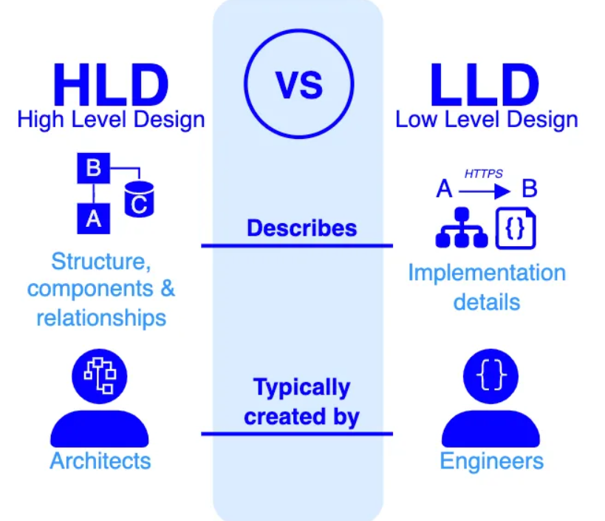
Client-Server Architecture Basics
Most modern systems follow the client-server model.

Client
- The client is the interface the user interacts with.
- It could be a web browser, mobile app, or desktop application.
- It sends requests to the server and displays responses.

Server
- The server is where the main logic resides.
- It processes requests, interacts with databases, and sends responses.
- Servers can be centralized or distributed across the globe.

How Do They Communicate?
- HTTP/HTTPS: The most common protocol for sending requests and receiving responses.
- WebSockets: Used for real-time communication, like in chat apps or live dashboards.
- RPC (Remote Procedure Call): Allows a client to call functions on a server as if they were local.
Example:
When you open a food delivery app:
- Client: You click on "Order Pizza."
- Server: Receives your request, checks availability, processes the order, and sends a confirmation back.

